The Hall Effect describes a phenomenon in which a voltage is created in a conducting material when current is run through it. This is due to the presence of a transverse magnetic field which, taking the cross product between the current and magnetic field, generates a force on charged particles in the material. The identity of the charge carries in the material can be understood by the sign of the Hall coefficient – which is simply the ratio of the induced electric field vs the product of the current and magnetic field. Negative charge carriers, electrons, will give the Hall coefficient a negative value, while positive charge carriers, holes, will give the Hall coefficient a positive value.

Without a magnetic field, the charged particles will flow straight. However, the presence of a magnetic field (and thus presence of the Hall Effect) induces a force on these particles. The forces that the charges particles feel is known as the Lorentz force – a cross product between magnetic field and current. This means that even if there is a magnetic field, it must be in the correct direction (perpendicular to the current) to have an effect. Slight differences in angle will diminish this effect, while a parallel field will not change the path of the charge carriers at all. Changing the path of the charge carriers causes a buildup of that charge on one side of the material, generating a separation of charges and thus an electric field in the material – creating a voltage in the material. One can also find the mobility of a material by multiplying its conductivity by the Hall coefficient.

Our experiment was designed to produce results from the Hall Effect. To achieve this, we started with a doped Germanium sample, measuring it to be 0.07cm thick. We then attached current and voltage probes to in as described in **[Figure 1]**. We needed to make sure that placing the sample in would always have the same face in the same direction, and that the magnetic field would be perpendicular to the current. After setting the current to 0.15mA, we set up a magnetic field with strength 1500 Gauss. We took data points of the voltage inside and outside of the field, incrementing our current by 0.15mA until we had 9 data points. We plotted the Hall voltage (difference between voltage inside field and voltage outside field) against current times magnetic field divided by the thickness of our sample **[Figure 2]**. Plotting also allowed us to find residuals to a linear fit, which we found had an R2 value of 0.998. This gives us a lot of confidence in the data that we collected. The slope equals our Hall coefficient (negative since the Germanium is n-doped) which was found to be -0.086. The Hall coefficient for Germanium is -0.0197. This resulted in us having an error of 326%.

By using **[Equation 1]** we were able to find the number of charge carriers. We did this by taking the inverse of our coefficient and dividing it by the charge of an electron. This was found to be 7.3x1019. Using the same source for the conductivity of our Germanium sample let us find the mobility of the sample using the equation described in the introduction. Our mobility was found to be 1.7x106 cm2/(Vs). The literature value, 3900 cm2/(Vs), let us calculate a deviation of 476%. One source of error is that the strength of the magnetic field was not uniform, so our values would change depending on where we put our sample. The incredible difference between our values and the literature values means that the literature value must be for an undoped Germanium sample. This makes sense due to the fact that our mobility is much higher and our Hall coefficient is also far greater (due to a lower bandgap).

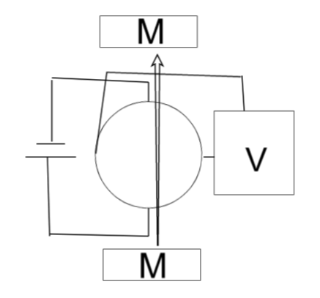

Figure 1: Our Experimental Setup

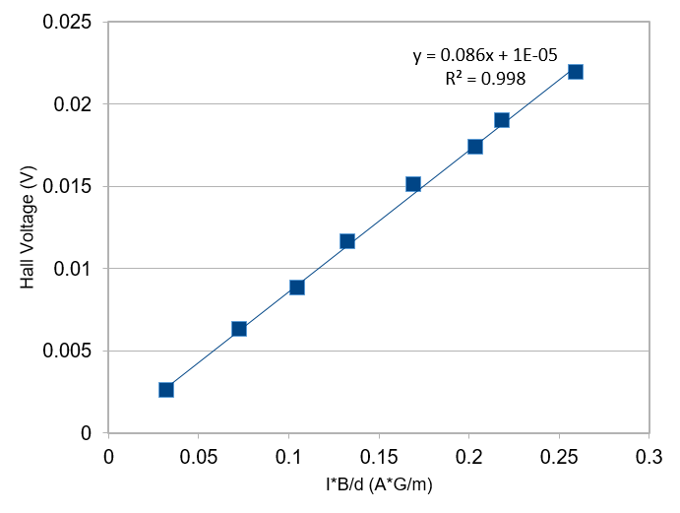

Figure 2: The Linearized Plot to find the Hall Coefficient

References:

1. <http://physics.wooster.edu/JrIS/Files/chandramouli.pdf>